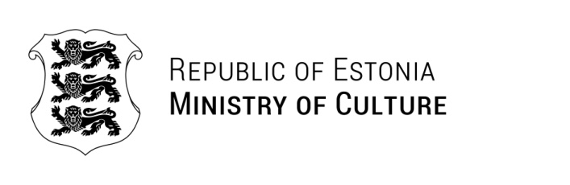

Ms Florence Haifene
Namibia Film Commission
Florence.Haifene@mict.gov.na | 02.07.2025 | No 9-10/714-1

Invitation to TAIEX study visit

As a follow-up to the fruitful discussions with representatives of the Namibia Film Commission during my visit to Windhoek in March 2025, the Ministry of Culture of the Republic of Estonia would like to invite a delegation formed by the Namibia Film Commission to a study visit to Estonia in November 2025.

The purpose of the potential study visit is to strengthen Namibia Creative and Culture Industries (CCI) national development policy contexts and support the achievement of Sustainable Development Goals. The focus of the potential visit is on film and audio-visual culture. The visit would include meetings and discussions with several CCI stakeholders representing government, civil society, private sector, and academia as well as a participation at PÖFF – one of the 15 A-list film festivals globally that takes place in Tallinn, Estonia 7-23 November 2025.

The visit depends upon a successful TAIEX funding application that must be submitted by the Namibia Film Commission to the European Commission prepared in cooperation with the European Union Delegation in Namibia and the Estonian Ministry of Culture. The cost of travel, accommodation, and per diem of the study visit’s participants would be covered by the European Commission. Usually, the TAIEX study visit lasts 2-5 days and the delegation consists of 3-5 officials from public administrations. The details of the TAIEX instrument and study visit agenda will be discussed and agreed in detail further on in the process.

Please do not hesitate to contact us in case you have any further questions.

Yours sincerely,

Kristiina Alliksaar
Secretary General

Anneli Vilu +372 6282235
Anneli.Vilu@kul.ee

